Metier description report

Josefine Egekvist, DTU Aqua

26 april, 2019

## Region: North Atlantic

## Metier: GNS_DEF_100-119_0_0 , years: 2015,2016,2017

Data source: RDB CE and CL data

**Number of trips by flag countries: ENG, WLS, SCT, FRA, CHA**

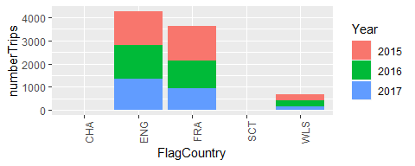

**Top 10 species landed by metier. The rest are summarised in “Other species”. Average yearly landings during the period 2015,2016,2017** 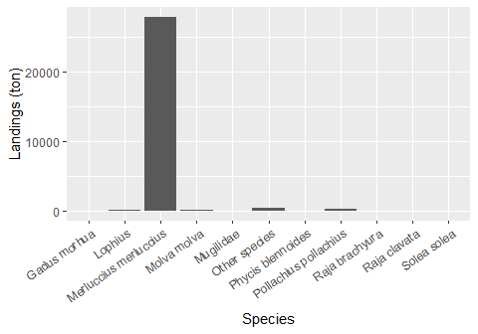

**Number of vessels by vessel length group:**

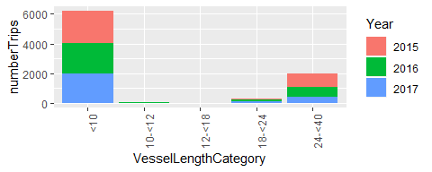

**Seasonal pattern of fishing activity: Number of trips by quarter**

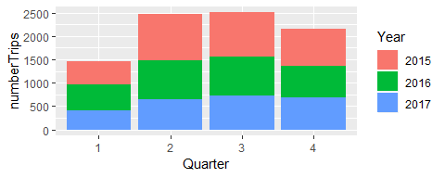

**Days at Sea by ICES rectangle, yearly average 2015-2017** 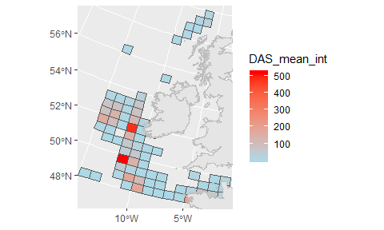

**Comments:**